**Lab 12 – SQL**

**This lab is from page 372, questions 1-6. No partial credit will be given. This lab is worth a total of 15 points.**

**Place all answers into ONE .sql file and upload to Canvas.**

1. **Create a view that defines a view named open_items that shows the invoices that haven’t been paid. This view should return four columns from the Vendors and Invoices tables: vendor_name, invoice_number, invoice_total, and balance_due (invoice_total – payment_total – credit_total). However, a row should only be returned when the balance due is greater than zero, and the rows should be in sequence by vendor_name. Then, run the script to create the view, and use SQL Developer to review the data that it returns. 40 rows total. (4 pts)**

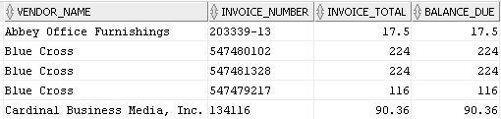

1. **Write a SELECT statement that returns all of the columns in the open_items view that you created in exercise 1, with one row for each invoice that has a balance due of $1,000 or more. (2 pts)**

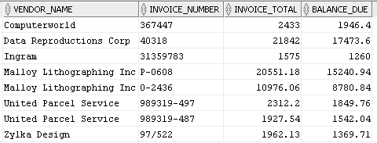

1. **Create a view names open_items_summary that returns one summary row for each vendor that contains invoices with unpaid balances due. Each row should include vendor_name, open_item_count (the number of invoices with a balance due), and open_item_total (the total of the balance due amounts), and the rows should be sorted by the open item totals in descending sequence. Then, run the script to create the view, and use SQL Developer to review the data that it returns. 16 rows total. (4 pts)**

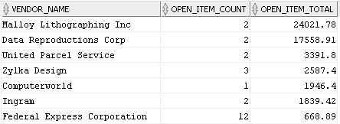

1. **Write a SELECT statement that returns just the first 5 rows in the open_items_summary view that you created in exercise 3. See first 5 in exercise 3. (2 pts)**
2. **Create an updatable view named vendor_address that returns the vendor_id, both address columns, and the city, state, and zip code columns for each vendor. Then, use SQL Developer to review the data in this view. 122 rows total. (3 pts)**

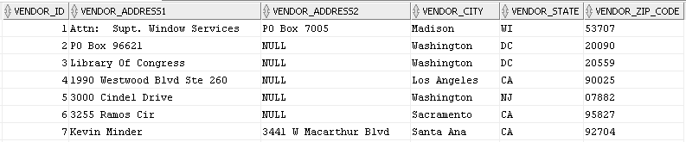

1. **Write an UPDATE statement that changes the address for the row with vendor_id 4 so the suite number (Ste 260) is stored in vendor_address2 instead of vendor_address1. Then, use SQL Developer to verify the change (you may need to click the Refresh button at the top of the Data tab to see the change). If this works correctly, go back to the tab for the UPDATE statement and click the Commit button to commit the change.**